Chapter 06 Neuron Network

Given (from the exercise 3)

Training examples
X₁ | X₂ | T
1 | 1 | 1
−1 | 1 | −1
1 | −1 | 1
−1 | −1 | −1

Perceptron model
- Threshold input = 1 → bias input $x_{0}=1$
- Initial weights:
$$w_{0}=0,w_{1}=0,w_{2}=0$$
- Learning rate:
$$α=0.25$$
- Activation function:
$$\text{sign}(x)$$
with:
$$\text{sign}(0)=-1$$

Perceptron forward propagation rule
$$z=w_{0}x_{0}+w_{1}x_{1}+w_{2}x_{2} \\ o=\text{sign}(z)$$

Weight update rule (Lecture 05)
For one example:
$$Δw_{i}=α(T-o)x_{i}$$

Part (i): Gradient Descent (batch learning)
Uses all training examples together
We compute updates using the sum over all examples

🔁 Iteration 1 (starting from w = 0,0,0)

Step 1: Forward propagation for all examples
Since all weights are zero:
$$z=0⇒o=\text{sign}(0)=-1$$
So for all examples:
$$o=-1$$

Step 2: Error term $T-o$
Example | T | o | T − o
(1,1) | 1 | −1 | 2
(−1,1) | −1 | −1 | 0
(1,−1) | 1 | −1 | 2
(−1,−1) | −1 | −1 | 0

Step 3: Weight updates (sum over all examples)

Bias $w_{0}$
$$Δw_{0}=α∑(T-o)x_{0}=0.25(2+0+2+0)=1$$

Weight $w_{1}$
$$Δw_{1}=0.25[(2⋅1)+(0⋅-1)+(2⋅1)+(0⋅-1)]=1$$

Weight $w_{2}$
$$Δw_{2}=0.25[(2⋅1)+(0⋅1)+(2⋅-1)+(0⋅-1)]=0$$

✅ Updated weights after Iteration 1
$$w_{0}=1,w_{1}=1,w_{2}=0$$

🔁 Iteration 2

Step 1: Forward propagation
X₁ | X₂ | z | o
1 | 1 | 2 | 1
−1 | 1 | 0 | −1
1 | −1 | 2 | 1
−1 | −1 | 0 | −1
(All predictions are now correct)

Step 2: Error terms
All:
$$T-o=0$$

✅ No weight change
$$w_{0}=1,w_{1}=1,w_{2}=0$$

✔ Gradient Descent result after 2 iterations
$$\boxed{w=(1, 1, 0)}$$

Part (ii): Stochastic Gradient Descent (SGD)
👉 Updates after each example
👉 Use examples one by one in table order

🔁 Iteration 1 – Example 1: (1,1), T = 1

Forward propagation
$$z=0⇒o=-1$$

Error
$$T-o=2$$

Update
$$Δw_{0}=0.25⋅2⋅1=0.5 \\ Δw_{1}=0.25⋅2⋅1=0.5 \\ Δw_{2}=0.25⋅2⋅1=0.5$$

Updated weights
$$w=(0.5, 0.5, 0.5)$$

🔁 Iteration 2 – Example 2: (−1,1), T = −1

Forward propagation
$$z=0.5-0.5+0.5=0.5⇒o=1$$

Error
$$T-o=-2$$

Update
$$Δw_{0}=0.25⋅(-2)⋅1=-0.5 \\ Δw_{1}=0.25⋅(-2)⋅(-1)=0.5 \\ Δw_{2}=0.25⋅(-2)⋅1=-0.5$$

Updated weights
$$w=(0, 1, 0)$$

✔ SGD result after first two updates
$$\boxed{w=\left(0, 1, 0\right)}$$

Extra Exercise for Logic:
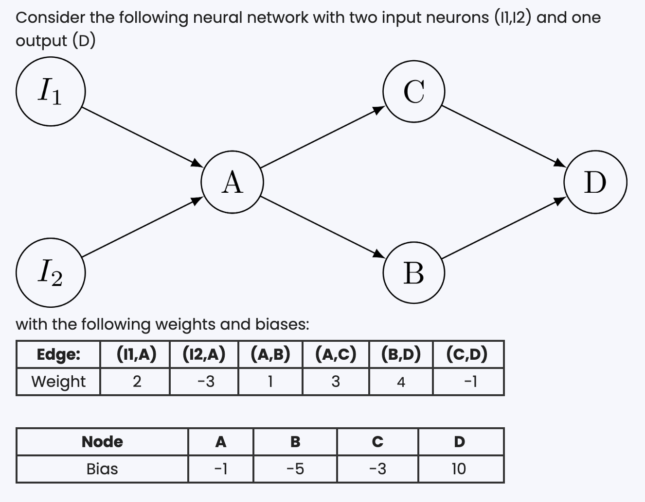
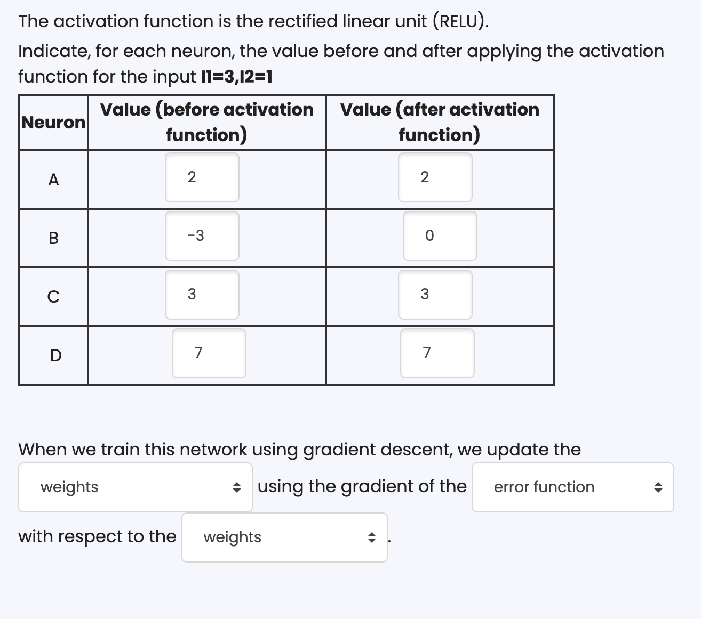
Solution:

1️⃣ Network structure (what connects to what)
- Inputs:
  - $I_{1}=3$
  - $I_{2}=1$
- Hidden neurons:
  - A
  - B
  - C
- Output neuron:
  - D
- Activation function (every neuron):
$$\text{ReLU}(x)=max⁡(0,x)$$

2️⃣ Weights and biases

Weights
- $I_{1}→A=2$
- $I_{2}→A=-3$
- $A→B=1$
- $A→C=3$
- $B→D=4$
- $C→D=-1$

Biases
- $b_{A}=-1$
- $b_{B}=-5$
- $b_{C}=-3$
- $b_{D}=10$

3️⃣ Step-by-step forward propagation

🔹 Neuron A

Before activation (weighted sum + bias)
$$z_{A}=(3⋅2)+(1⋅-3)+(-1) \\ z_{A}=6-3-1=\boxed{2}$$

After ReLU
$$A=\text{ReLU}(2)=\boxed{2}$$
✔ This matches the given value in the table.

🔹 Neuron B

Before activation
$$z_{B}=(A⋅1)+(-5) \\ z_{B}=(2⋅1)-5=\boxed{-3}$$

After ReLU
$$B=\text{ReLU}(-3)=\boxed{0}$$

🔹 Neuron C

Before activation
$$z_{C}=(A⋅3)+(-3) \\ z_{C}=(2⋅3)-3=\boxed{3}$$

After ReLU
$$C=\text{ReLU}(3)=\boxed{3}$$

🔹 Neuron D (output)

Before activation
$$z_{D}=(B⋅4)+(C⋅-1)+10 \\ z_{D}=(0⋅4)+(3⋅-1)+10 \\ z_{D}=0-3+10=\boxed{7}$$

After ReLU
$$D=\text{ReLU}(7)=\boxed{7}$$

4️⃣ Final filled table
Neuron | Before activation | After ReLU
A | 2 | 2
B | −3 | 0
C | 3 | 3
D | 7 | 7

Extra Exercise for Logic
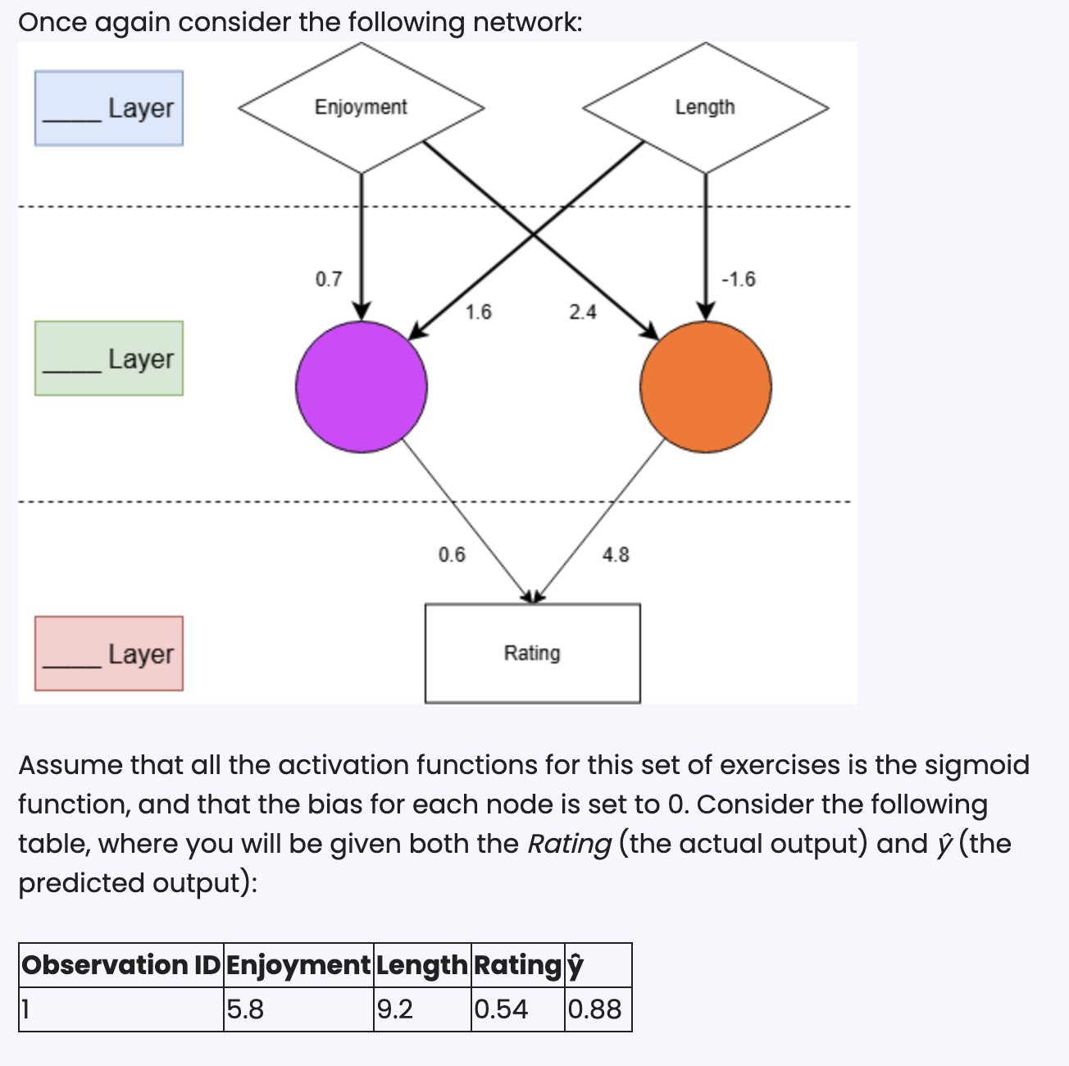
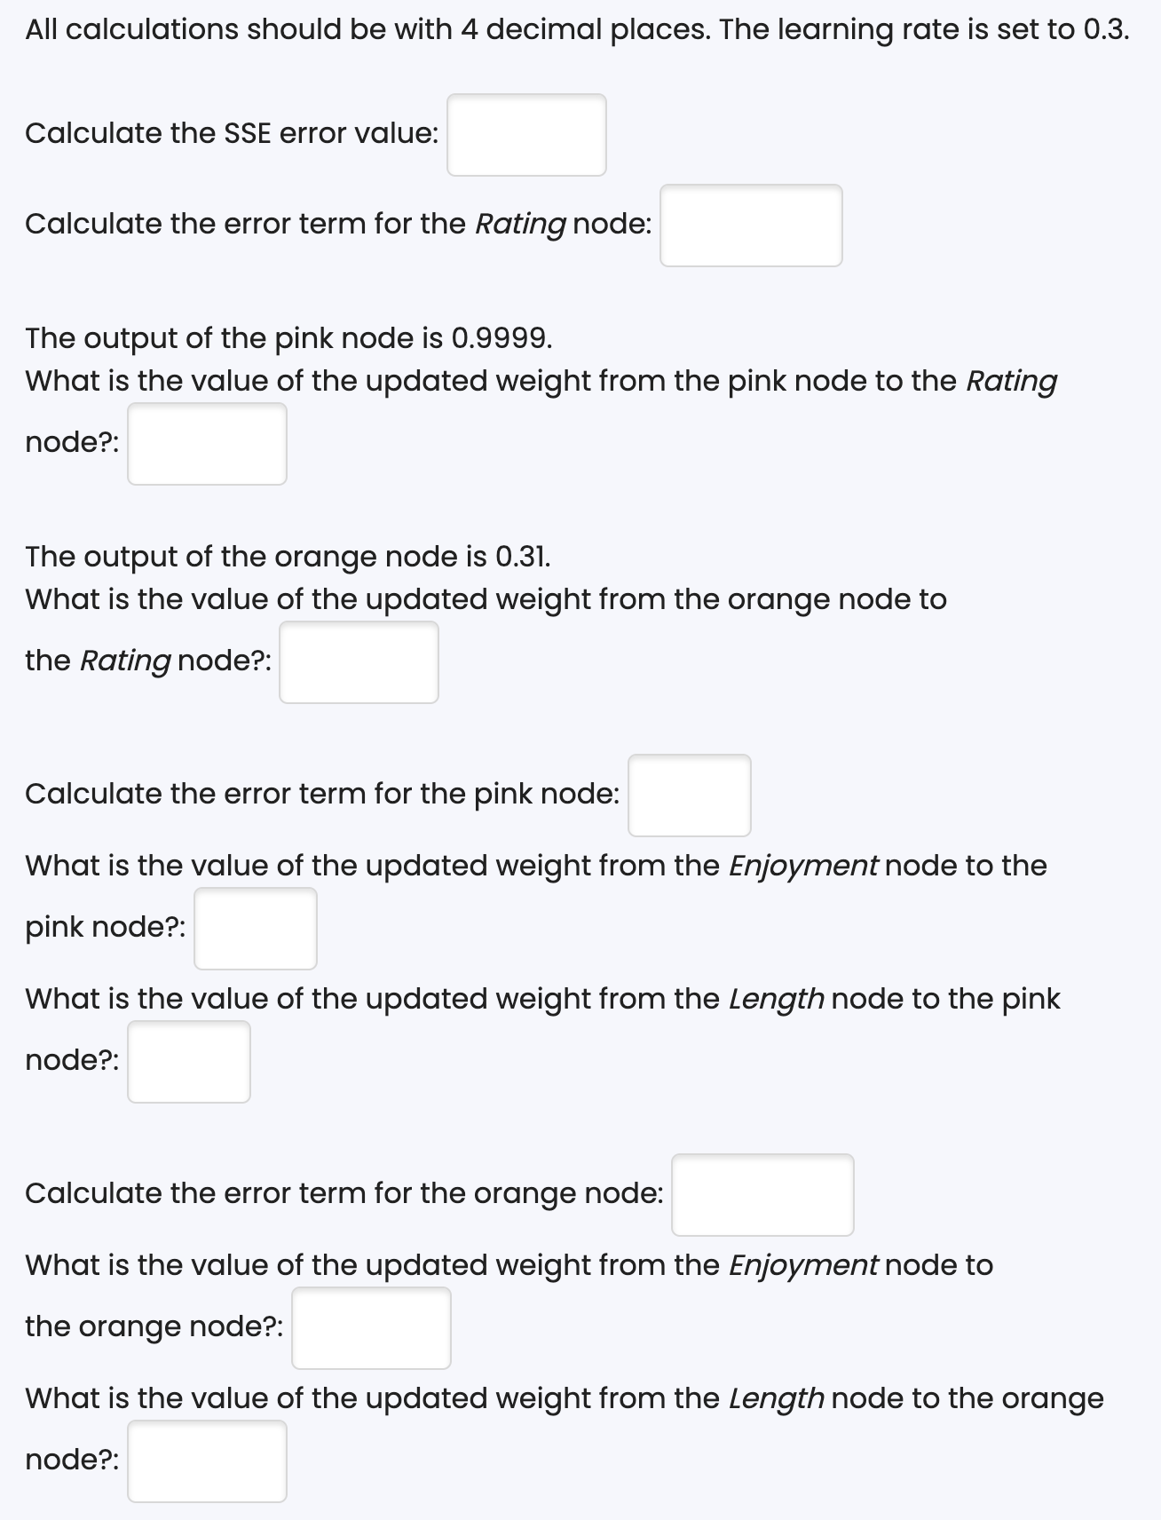

Solution

Given information

Inputs
- Enjoyment = 5.8
- Length = 9.2

Target (actual output)
- Rating = 0.54

Predicted output
- ŷ = 0.88

Learning rate
- α = 0.3

Activation function (EVERY node)
$$σ(x)=\frac{1}{1+e^{-x}}$$

Bias
- All biases = 0

🔵 Step 1: Compute the SSE error (HOW wrong are we?)

Formula (from Lecture 05)
$$\text{SSE}=\frac{1}{2}(y-\hat{y})^{2}$$

Plug in values
$$y=0.54,\hat{y}=0.88 \\ y-\hat{y}=0.54-0.88=-0.34$$
Square it:
$$\left(-0.34)^{2}=0.1156\right.$$
Multiply by ½:
$$\text{SSE}=\frac{1}{2}⋅0.1156=\boxed{0.0578}$$
✅ Interpretation:
The network is wrong by 0.0578.

🔵 Step 2: Error term for the OUTPUT node (Rating)
This tells us:
“How much should the output node change?”

2.1 Sigmoid derivative (VERY IMPORTANT)
For sigmoid:
$$σ^{'}(x)=σ(x)(1-σ(x))$$
We already know:
$$\hat{y}=0.88$$
So:
$$σ^{'}(0.88)=0.88⋅(1-0.88) \\ =0.88⋅0.12=0.1056$$

2.2 Output error term formula
$$δ_{D}=(\hat{y}-y)⋅σ^{'}(\hat{y})$$
Plug in values:
$$δ_{D}=(0.88-0.54)⋅0.1056 \\ =0.34⋅0.1056=\boxed{0.0359}$$
✅ Meaning:
The output neuron should be corrected by 0.0359.

🔵 Step 3: Update weights INTO the output node
General update rule:
$$w_{\text{new}}=w_{\text{old}}-α⋅δ⋅\text{input}$$

3.1 Pink → Rating

Given
- Old weight = 0.6
- Pink output = 0.9999

Calculate change
$$Δw=0.3⋅0.0359⋅0.9999 \\ Δw=0.0108$$

Update
$$w_{\text{new}}=0.6-0.0108=\boxed{0.5892}$$

3.2 Orange → Rating

Given
- Old weight = 4.8
- Orange output = 0.31
$$Δw=0.3⋅0.0359⋅0.31 \\ Δw=0.0033 \\ w_{\text{new}}=4.8-0.0033=\boxed{4.7967}$$

🔵 Step 4: Error term for the PINK hidden node
Hidden nodes do not see the true output directly.
They receive error from the next layer.

4.1 Formula for hidden node error
$$δ_{h}=σ^{'}(h)⋅∑(w⋅δ_{\text{next}})$$

4.2 Sigmoid derivative of pink node
Pink output:
$$h=0.9999 \\ σ^{'}(0.9999)=0.9999(1-0.9999) \\ =0.9999⋅0.0001=0.0001$$

4.3 Multiply with downstream influence
Pink → Rating weight = 0.6
$$δ_{\text{pink}}=0.0001⋅(0.6⋅0.0359) \\ =0.0001⋅0.0215≈\boxed{0.0000}$$
✅ Meaning:
Pink node is saturated → almost no learning.

🔵 Step 5: Update weights INTO pink node
Since error ≈ 0:

Enjoyment → Pink
$$Δw=0.3⋅0.0000⋅5.8=0 \\ w=\boxed{0.7000}$$

Length → Pink
$$Δw=0.3⋅0.0000⋅9.2=0 \\ w=\boxed{1.6000}$$

🔵 Step 6: Error term for the ORANGE hidden node

6.1 Sigmoid derivative
Orange output:
$$0.31 \\ σ^{'}(0.31)=0.31(1-0.31) \\ =0.31⋅0.69=0.2139$$

6.2 Multiply downstream error
Orange → Rating weight = 4.8
$$δ_{\text{orange}}=0.2139⋅(4.8⋅0.0359) \\ =0.2139⋅0.1723=\boxed{0.0369}$$

🔵 Step 7: Update weights INTO orange node

Enjoyment → Orange
$$Δw=0.3⋅0.0369⋅5.8 \\ =0.0642 \\ w=2.4-0.0642=\boxed{2.3358}$$

Length → Orange
$$Δw=0.3⋅0.0369⋅9.2 \\ =0.1019 \\ w=-1.6-0.1019=\boxed{-1.7019}$$

✅ FINAL SUMMARY (ALL RESULTS)
Quantity | Value
SSE | 0.0578
δ Rating | 0.0359
Pink → Rating | 0.5892
Orange → Rating | 4.7967
δ Pink | 0.0000
Enjoyment → Pink | 0.7000
Length → Pink | 1.6000
δ Orange | 0.0369
Enjoyment → Orange | 2.3358
Length → Orange | −1.7019

Extra Exercise 2024
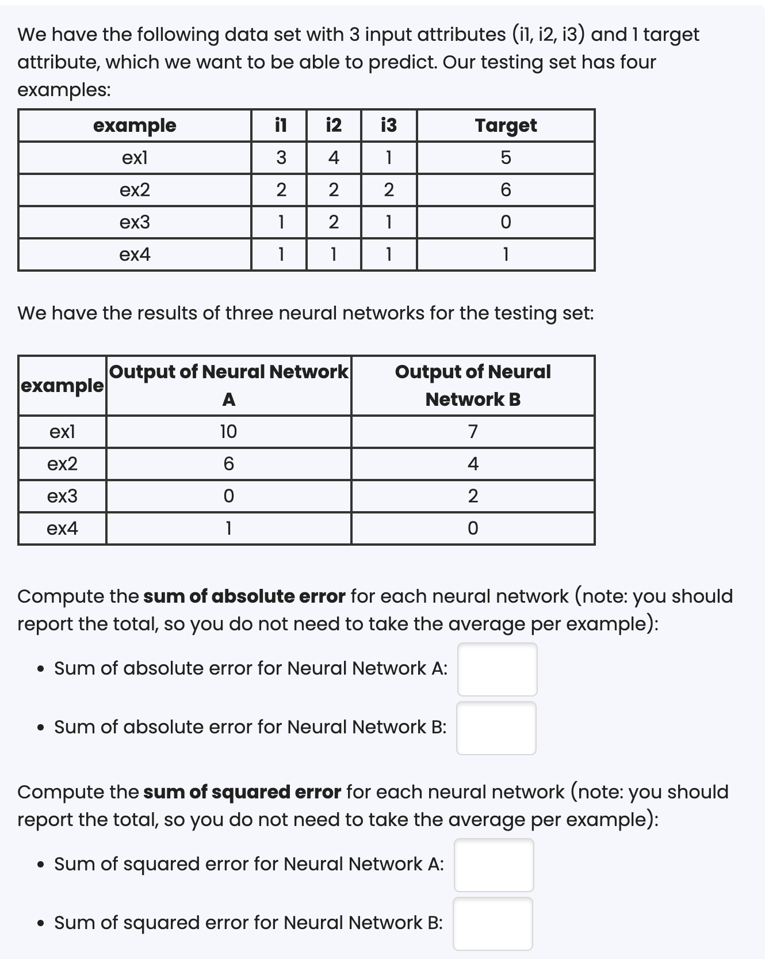
Which is the best neural network if we want to ensure that there is no large deviation for the target in any example?
Answer: The neural network with lowest sum of squared error
Solution:

Absolute Error (AE)

Formula
For one example:
$$\text{Absolute Error}=∣y-\hat{y}∣$$
Where
- $y$= target
- $\hat{y}$= predicted output

Sum of Absolute Error (SAE)
$$\text{SAE}=∑∣y-\hat{y}∣$$

🔹 Neural Network A — Absolute Errors
Example | Target | Prediction | Absolute Error
ex1 | 5 | 10 | -
ex2 | 6 | 6 | -
ex3 | 0 | 0 | -
ex4 | 1 | 1 | -
✅ Sum of Absolute Error (A):
$$5+0+0+0=\boxed{5}$$

🔹 Neural Network B — Absolute Errors
Example | Target | Prediction | Absolute Error
ex1 | 5 | 7 | -
ex2 | 6 | 4 | -
ex3 | 0 | 2 | -
ex4 | 1 | 0
✅ Sum of Absolute Error (B):
$$2+2+2+1=\boxed{7}$$

3️⃣ Squared Error (SE)

Formula
For one example:
$$\text{Squared Error}=(y-\hat{y})^{2}$$

Sum of Squared Error (SSE)
$$\text{SSE}=∑(y-\hat{y})^{2}$$
⚠️ Note: NO ½ here, because the question explicitly says “sum of squared error”, not training loss.

🔹 Neural Network A — Squared Errors
Example | Target | Prediction | Squared Error
ex1 | 5 | 10 | $$\left(5-10)^{2}=25\right.$$
ex2 | 6 | 6 | $$\left(6-6)^{2}=0\right.$$
ex3 | 0 | 0 | $$\left(0-0)^{2}=0\right.$$
ex4 | 1 | 1 | $$\left(1-1)^{2}=0\right.$$
✅ Sum of Squared Error (A):
$$25+0+0+0=\boxed{25}$$

🔹 Neural Network B — Squared Errors
Example | Target | Prediction | Squared Error
ex1 | 5 | 7 | $$\left(5-7)^{2}=4\right.$$
ex2 | 6 | 4 | $$\left(6-4)^{2}=4\right.$$
ex3 | 0 | 2 | $$\left(0-2)^{2}=4\right.$$
ex4 | 1 | 0 | $$\left(1-0)^{2}=1\right.$$
✅ Sum of Squared Error (B):
$$4+4+4+1=\boxed{13}$$

4️⃣ Final results (clean summary)
Metric | Network A | Network B
Sum of Absolute Error | 5 | 7
Sum of Squared Error | 25 | 13

Extra Exercise 2023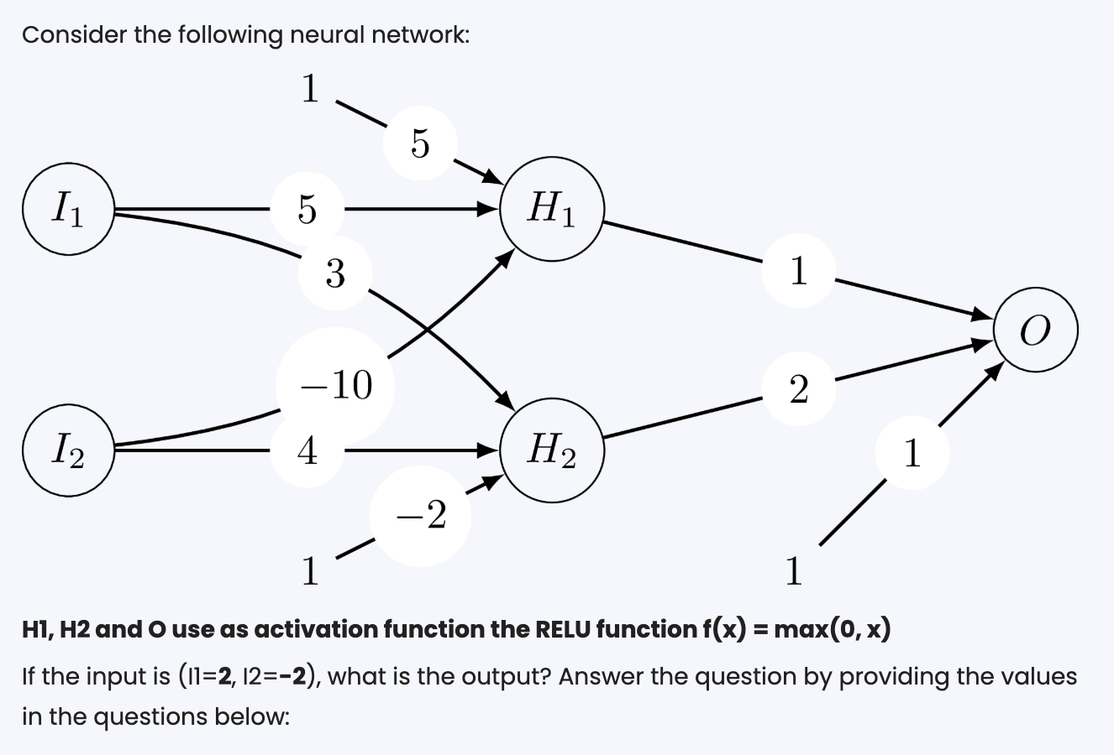
What is the value of neuron h1?
What is the value of neuron h2?
What is the value of neuron O?
If we are using a mean-squared error, assuming that the desired output is 16, what is the error?

1️⃣ Compute neuron H1

Weights into H1
- $I_{1}→H_{1}=5$
- $I_{2}→H_{1}=-10$
- Bias input $1→H_{1}=5$

Weighted sum (before ReLU)
$$z_{H1}=(2⋅5)+(-2⋅-10)+(1⋅5) \\ =10+20+5=35$$

After ReLU
$$H_{1}=max⁡(0,35)=\boxed{35}$$
✅ Answer Q10 (h1): 35

2️⃣ Compute neuron H2

Weights into H2
- $I_{1}→H_{2}=3$
- $I_{2}→H_{2}=4$
- Bias input $1→H_{2}=-2$

Weighted sum
$$z_{H2}=(2⋅3)+(-2⋅4)+(1⋅-2) \\ =6-8-2=-4$$

After ReLU
$$H_{2}=max⁡(0,-4)=\boxed{0}$$
✅ Answer Q11 (h2): 0

3️⃣ Compute output neuron O

Weights into O
- $H_{1}→O=1$
- $H_{2}→O=2$
- Bias input $1→O=1$

Weighted sum
$$z_{O}=(35⋅1)+(0⋅2)+(1⋅1) \\ =35+0+1=36$$

After ReLU
$$O=max⁡(0,36)=\boxed{36}$$
✅ Answer Q12 (O): 36

🔹 PART B: Mean Squared Error (Q13)

Given
- Desired output = 16
- Predicted output = 36

MSE formula (single example)
$$\text{MSE}=(y-\hat{y})^{2} \\ =(16-36)^{2}=(-20)^{2}=\boxed{400}$$
✅ Answer Q13: 400

